

Copyzing.com

Let our content capture you

About me

I have written reams of copy, oodles of marketing blurb, issued several hundred press releases and penned plenty of articles during my 20 years in PR and content production.

I’ve been used to working to unfeasibly tight deadlines under the pressure-cooker of agency-life but have also experienced client-side where infinitesimal rounds of approvals with multiple stakeholders can mean it takes longer to get digital content approved.

I have worked on high-profile brands and blue chips such as Virgin Media, npower, Sony PlayStation, Early Learning Centre, Lloydspharmacy and Direct Line as well as SMEs which include a B2B optical equipment specialist, the launch of a horse trainer and a jewellery business. I’ve even launched a new music festival, creating all copy myself from fund-raising pitches to the creation of an entire website and the final 20-page programme in just 3 months.

My key strength is being able to engage with my target audience quickly and effectively. I can create high turn-out to events, generate sales, improve page views and make dull, lifeless content more dynamic. I constantly refine my work and make the most of UX and analytics teams to help hone my content, where possible. As an experienced communicator I enjoy being part of a wider team and working in tandem with different departments and the resulting challenges that can bring.

|  |  |  |  |  |
| --- | --- | --- | --- | --- |
|  |  |  |  |  |
|  |  |  |  |  |
|  |  |  | Image result for virgin media logo black and white |  |

Contents

Great copy is artful, persuasive yet concise. Powerful writing jumps off the page, changes, motivates, inspires, and builds a rapport. Well-written words can induce empathy, anticipation and desire; quite simply copy is your power tool in the art of selling.

Take a look at some sample copy which I have written to successfully promote consumer products and influence buyers and industry influencers. You’ll find digital content, competitions, PR features, trade releases and more, this is just a taster of what I can do.

# Network Build scheme, Virgin Media

The brief: To create a new scheme which would allow customers in the Test Valley to be able to sign up to pay £300 to build the necessary infrastructure before they could sign up for services.

This involved linking up with multiple teams and stakeholders around the business, including the Legal team to ensure that the scheme could meet a tight deadline.

Result: Test Valley registrations – 1388 in 1 month, which netted over half a million pounds

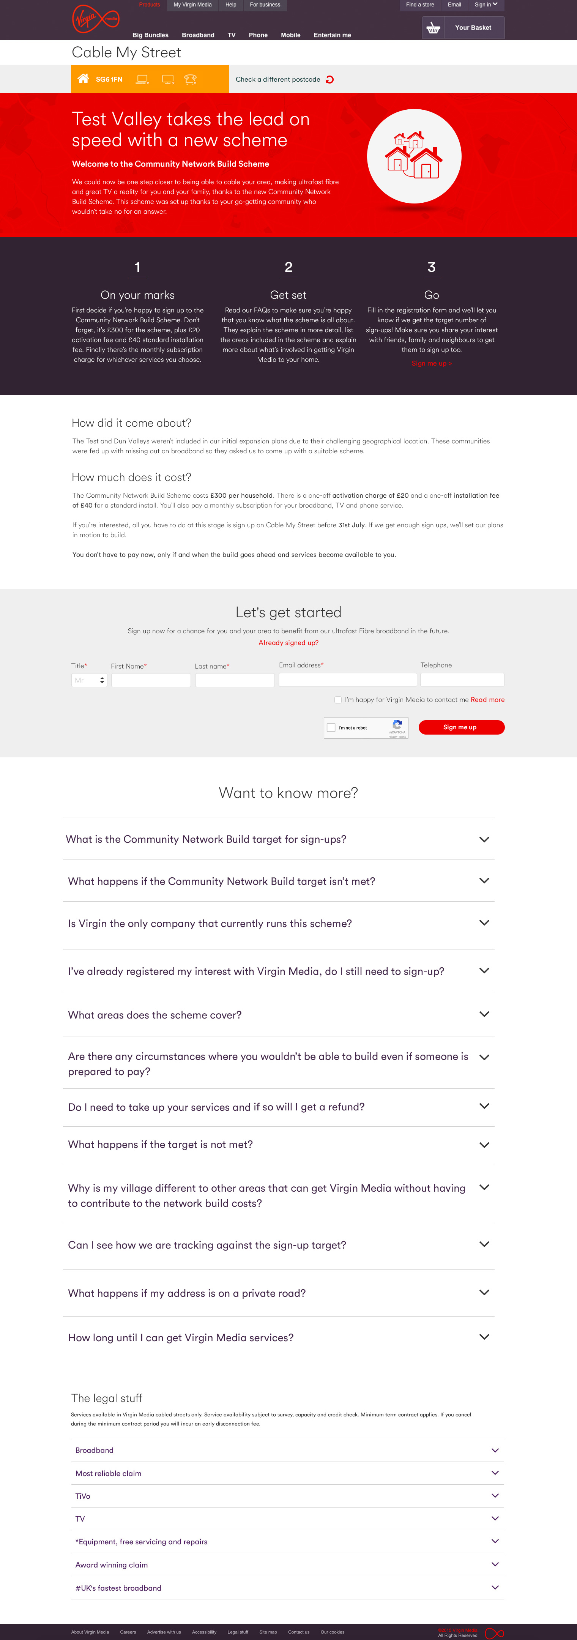

# iPhone X Launch, Virgin Media

The brief: To create a pre-register landing page for potential customers, keeping the page clean and simple with an informative yet persuasive headline.



# Corporate Responsibility: Charity Partnership Online Content

The brief: To write inspirational content on npower.com to promote the partnership between npower and Macmillan and a new fundraising initiative called ‘Summer Lights’. Working with PR agency Golin, we created a blend of images and content from key influencers and bloggers to bring the campaign to life.

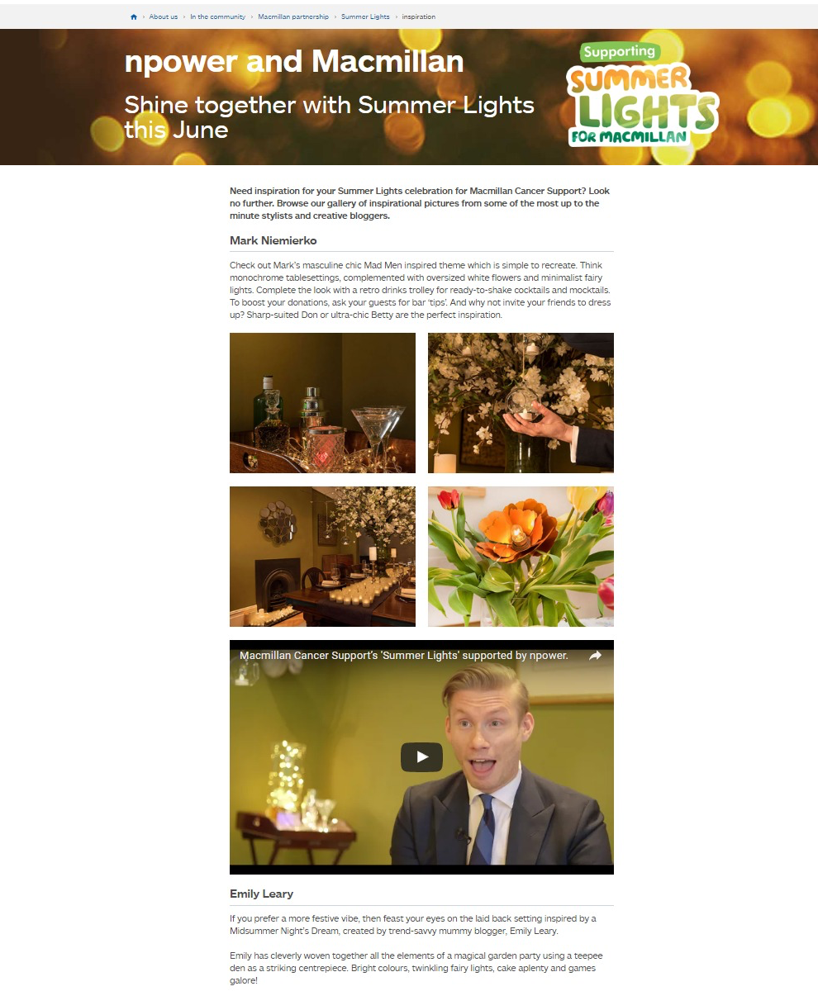

# 

# Consumer Product Copy

The brief: To write a press release for consumer men's magazines, lifestyle and TV magazines to accompany a product release with the aim of generating positive reviews and creating a consumer buzz about the game.

|  |
| --- |
| **Top Gun: Hornet's Nest is guaranteed to take your breath away….**  As an American action adventure movie it was one of the films of the 80's. Now Maverick's back in an epic action adventure with a storyline produced especially for the small screen; your computer monitor to be exact. If you loved Top Gun, you'll love Top Gun: Hornet's Nest.  The game takes the pilot to a new level of intense flight and fight action against threatening aerial forces and dangerous ground targets. As Maverick you must get to grips with 30 menacing missions and prepare yourself to tackle the toughest opponents in three different peril filled environments.  You can feel the full throttle thrills in a mind-blowing mix of both air-to-air and air-to-ground assignments. With easy to master controls and easy to manage weapons and radar, flying couldn't be easier.  Add a multi-player facility with an action packed storyline, high-res 3d graphics and realistic flying sequences and you could be in for one hell of a ride! |

# Specialised Product Copy

The Brief: To create multiple inlays for a traditional range of notebooks inspired by quintessentially English colours with a historical or nationalistic twist. (stockists to include Harrods and other leading department stores).

The client provided some examples of copy to provide inspiration and specified the colours that they wanted to focus on. We found inspiration in English history and British culture and find interesting facts related to colours which we could mould into mini-stories for the inlays. The strict 160 word count was also a challenge. Below are three examples of the 20 strong colour palette which we completed in just one week.

|  |
| --- |
| ***Sage Green notebook***  **SAGE, NOT JUST FOR STUFFING**  Sage is a perennial, fragrant herb and a longstanding favourite of English cottage gardens and herb beds. An old country rhyme tells us that ‘he who drinks sage in May, shall live for aye.’ Whilst it can’t guarantee that you can live for ever, this traditional garden herb has been proven to improve memory when taken on a regular basis in tea or supplement form.  Today many of us are only familiar with sage as a flavour which combines well with onions to make stuffing for our Christmas turkey. However, it is regularly given as treatment for many illnesses ranging from eczema to Alzheimer’s. In 1652, a description of sage by herbalist, Nicholas Culpepper, reads: 'It also heals the memory, warming and quickening the senses.'  If your memory is in need of a boost why not brew up some sage tea or alternatively carry a British Notebook as a handy aide-memoire instead. |

# Blogs

This blog was written for a jewellery website. It features Strictly Come Dancing, as a way of engaging with fans of jewellery for dancers and special occasion wear. This ensures constant engagement with site users and encourages them to return to the site.

|  |
| --- |
| **Glitterball, Glitterball who will shine the brightest of them all?**  Strictly never fails to cheer us through the winter months with its gallons of fake tan imbuing our screens with a warming, festive glow. The encrusted plumage of the contestants, encased in lycra and chiffon dusted in Swarovski’s finest, helps lift our sagging spirits and give us something to focus on beyond sludge coloured parkas and rocketing central heating bills which are our daily reality.  Even self-confessed tomboys such as Caroline Flack succumb completely to the Strictly sparklathon; happily encased in citrus rhinestones she swooped and swivelled her way through her final Charleston earlier this year and wowed us with her emotionally-wrought balletic showdance to Angels.  With the new contestants just announced, who do you think will be keeping us glued to our sets this year, (as firmly as the Swarovski crystals are welded to their outfits?). Which celebs will dazzle us with their dramatics a la Caroline and Pasha and infiltrate our living rooms with the infectious enthusiasm of ‘snake-hips’ Jake and Janette?  Will Helen George’s early ballet training give her the edge over uber-competitive Kirsty Galacher or will Jamelia’s dance moves gleaned from her pop-star dom help her to muscle her way onto the ballroom ahead of boxer Anthony Ogogo and six-pack toting singer Peter Andre.  We can’t wait to watch the dramas unfold and find out who’ll get a ten from Len or disgrace themselves by being a daaaaaancing disaaaaster. |

# Events Programme

Featured below is a programme snippet from an up and coming music festival. The music round-up below features a selection of artists and bands who were interviewed prior to the event in order to promote them in the programme and via the website also produced by CopyZing. In addition, we worked with a design agency to put together the layout of the whole publication.

|  |
| --- |
| **Sultry songstress with soul**  A cross between Amy Winehouse and Carmen Miranda, Vanessa oozes retro style in spades; her husky voice belts out Amy classics with soul. Vanessa has a strong following around all the local venue circuits where she is well known for being the sultry songstress with soul. |
| **Up-tempo, electro-pop, inspired by the great American songwriters such as Bob-Dylan.** The Terrapins are regulars on the local festival scene, appearing at the Lunar Festival last year to great acclaim. This year the 5 piece band are featuring favourite hits by Paolo Nutini and the Grateful Dead as well as their own music inspired by the local legend Who Put Bella in the Witch Elm. |
| **Harmonic Acoustic Duo**  Meet Tale Lights, our (as-yet unsigned) dynamic duo Ben Keen and Dan Francois Smith, who are featuring at Hagfest; their soulful acoustic sound is influenced by up and coming Nashville artists.  The boys have recently made a trip Stateside to promote their forthcoming single, following their success at the recent Take That gig at the Forum Live, Genting Arena. |
| **He’s got the X Factor**  Danny Dearden is a singer/songwriter from Manchester. Danny has always had a passion for music, singing at local events and getting interest from an independent record label and becoming part of a band. Though his band split management company 'UpSide UK' decided to take Danny on and develop him as a solo artist.  Since then he's been working with some top Producers around the world, mostly in Sweden and Dubai writing and recording tracks for his Debut Album. |

# Competition Copy

Competition copy is an important part of the PR arsenal for consumer products as it directly engages readers and draws them in. It works best when directly addressed to the reader, with tantalising touches of detail added and packaged into a simple format. This competition achieved our aim of attracting a newer, younger customer base to Cookes, more cheaply and effectively than an advertising slot.

|  |
| --- |
| All mums love a little retail therapy so why not put a spring in your mum’s step this Mother’s Day by entering our competition to win this fabulous prize courtesy of [Company name]. The lucky winner will receive £300 of [Company name] vouchers to spend on her mum in store. In addition they will be treated to a relaxed atmosphere and tasty local homemade cakes.  [Company name] invites you to browse at your leisure but whilst you are here why not have a look for that perfect Mother’s Day gift from the [Company name] Home Comforts Range; a collection of irresistable home accessories. |

# PR Feature

Below is an example of a PR feature, placed in a glossy colour A3 magazine with a high ABC1 profile, perfect for the target audience.

The client brief was to come up with a trend article for Spring which would showcase some of the products available in-store to improve footfall and coincide with the Spring advertising campaign. The next challenge was to ‘sell-in’ to a regional lifestyle magazine and get coverage as an editorial piece rather than pay for advertising. This article showcases our persuasive style and attention to detail. How did we do it? We researched styles and colour trends on Pinterest, Houzz and many other leading homeware sites. Next, we carried out competitor research and analysed style leading brands such as John Lewis, Farrow and Ball, Next, B and Q as well as smaller boutique interior designs for inspiration and tone.

Finally, we liaised with partner brands to source the most current attractive images which highlighted trends mentioned in the feature. This generated a piece worth around £2K in advertising costs, which they could use on their website as well as for future trend pieces.

|  |
| --- |
| [**Stay Serene this Spring with Restorative, Relaxing Green**](http://www.cookesfurniture.co.uk/article/6-stay-serene-this-spring-with-restorative-relaxing-green)  Be inspired by fresh greens this Spring! Taking a cue from nature, using green in the home can create a calming reflective atmosphere, from the peaceful tranquillity of forests, to the feel-good factor of strolling through a lush, spring meadow.  Green is traditionally the colour of renewal and rejuvenation and without fail has an impact on Spring trends and homeware inspiration.  It comes in many guises from vibrant citrus lime to more sedate mossy hues.  Here’s our pick of the top three interior trends this Spring, to help you create a green, serene haven in your living space.  **Elemental Nature**  The overriding trend in interiors for 2015 is all about creating a natural haven in your home that helps you switch off from the stresses of the day and re-connect with nature. Greens are key colours in this trend, supported by greys, browns and other hues which reflect the natural landscape.  Shades from dark forest to pale aqua work well alongside natural elements such as exposed wooden flooring, furniture featuring rustic textures, stone, leather, linen and foliage.  The [G Plan Washington](http://www.cookesfurniture.co.uk/g-plan-upholstery-washington-leather-3-seater-double-recliner-sofa/p40) range of leather reclining sofas and armchairs is available in natural lichen. |
| **The Next Zen-eration**  If you are choosing a green to create a zen-like calming effect make sure you opt for shades which are paler and less saturated, particularly on your walls. Cool greens can be dreamy and meditative while beige greens and yellow greens are more stress relieving and relaxing, especially in the softer shades.  Zen colour schemes aren’t afraid to mix natural elements, neutral colours and rustic textures, creating a fresh, inspiring décor. For example contemporary man-made materials that mimic solid wood, metal and natural stone textures can be blended with colourful patterns and fabric prints. Pale greens also look great as a backdrop for driftwood furniture and lighting fixtures in grey colour tones.  The beautiful embellished ‘[Hope](http://www.cookesfurniture.co.uk/hope/p961)’ would fit beautifully into a zen colour scheme.  **Modern Mid-Greens**  Timeless mid-greens, such as Farrow and Ball’s ‘Breakfast Room Green’, are perfect for those who want to up the style stakes but don’t want a drastic makeover. These chameleon shades work well with modern geometrics and bold prints. They can be used on walls, furniture upholstery or accessorising lamps and vases.  Easy on the eye, these shades are particularly popular amongst mid-century modern lovers and Scandi-style aficionados. Clean lines and tapered legged furniture like the ErcolArtisan lamp table are perfect for creating a relaxed, uncluttered look.  **Invite spring into your home**  With a little planning and drawing inspiration from these themes, you can create a relaxing haven full of interest and depth, which will draw green-eyed looks from your visitors. Our experienced sales advisors will be only too happy to talk you through the process of choosing fabrics and upholstery options, to help you freshen up a room with some serene seasonal greens.  View more of our serene greens on our Pinterest board. | |

# Trade Press Release

It’s always important to keep the trade press up to speed with your company news. Why? It showcases your work to prospective partners, investors and suppliers. Also any coverage or links can be added to your website, which will ultimately boost your SEO. Trade press releases don’t have to be dull. They simply require an angle and its always a good idea to present the new partnership deal or story as part of a wider context; part of a nationwide sales strategy or trend in order to get the trade press interested.

|  |
| --- |
| **[Company name] to Host New Sustainable Sofa Range**  [Company name], [location], is to exclusively host a luxurious new sofa range across the Midlands and the South, which is both more environmentally friendly and claims to be more comfortable than traditional ranges.  Spink & Edgar Upholstery, which is owned by Great Britain’s most established and innovative bed makers Harrison Spinks, has removed 60% of the foam and other manmade materials within the seat cushions and throughout the frame. Foam and fibre, which is not sustainable and flattens over time, has been replaced with award-winning pocket sprung core technology; ensuring endless comfort while preserving the sofa’s plumped appearance.  “Using this technology, we have created a beautiful sofa range with unrivalled comfort that will stand the test of time. There no longer has to be a compromise between comfort and style,” comments Commercial Director of Spink & Edgar Upholstery, Jo Moore.  [MD name], Marketing Director, [Company name], [location] added:  “At [Company name] we were impressed by the product, and not just by the quality and attention to detail, but also by the fact that it is sustainable. As a family firm, which spans four generations, we are very keen to work with suppliers that can provide new and exciting products which will appeal to the next generation of customers. We would like to improve our environmental credentials and see Spink & Edgar as a showcase sustainable product which doesn’t compromise on the quality or style that our customers expect. Following the launch of this, we hope to look at other environmentally friendly ranges by the autumn.”  Harrison Spinks’ pocket spring technology, used within the new furniture, has received two Queen’s Awards for Enterprise in Innovation and Sustainable Development. Capitalising on the luxury bed makers 175 years’ experience, Spink & Edgar Upholstery has created a range of sofas which carries across the quality, heritage and commitment to innovation from its parent company.  Each Spink & Edgar sofa is not only handcrafted in Yorkshire by a team of skilled craftsmen, but is more sustainable than other sofas on the market due to the 60% less foam and natural fillings used. Jo adds: “Our ultimate goal is to eventually remove 100% of the foam used within the sofas and replace it with completely natural products.”  Yorkshire-based Spink & Edgar manufactures everything onsite from the award-winning springs and FSC wooden frames to growing the natural fillings on its farm.  Prices for the new Spink & Edgar sofa range start from £2,000 and will be stocked at [Company name] in Birmingham and Dorset as well as the exclusive showroom in Yorkshire.  For more information about the sofas visit [url] |

Survey Summaries

So you’ve commissioned a survey but not got time to trawl the results? Let us crunch the numbers and wrap up the results in a comprehensive overview. We can tailor this for boardroom summaries or press releases, so that you get the value from the survey that you need. See our sample survey for Cookes furniture below.

|  |
| --- |
| [**[Company name] Survey Reveals Christmas Consumer Shopping Habits in the Midlands**](http://www.cookesfurniture.co.uk/article/1-cookes-survey-reveals-christmas-consumer-shopping-habits-in-the-midlands)  A survey from Midlands homeware retailer, [Company name], has revealed that 61% of us across the Midlands enjoy our annual Christmas shopping excursions and nearly a third (29%) enjoy the build up more than Christmas Day itself. This fits in with a European wide survey* which has found the British to be top of the Christmas shoppers out of the whole of Europe, with plans to spend £350 on gifts for family and friends this Christmas.  **Tidings of Discomfort** Only 12% of those surveyed found shopping too stressful to enjoy at all. The biggest mood dampener was jostling crowds, which applied to half of respondents across the Midlands.  Another issue which was held responsible for curtailing our Christmas spirit was decorations going up too early with over a third (34%) citing this as their major bugbear. An inevitable problem for shoppers was parking, with almost 30% finding this the most unbearable part of their Christmas shopping spree. Other peeves were overheated shops, hyperactive children and blaring Xmas music.  48% of Midlanders profess to enjoy the big day itself, while 26% prefer Christmas Eve celebrations instead.  Only a fifth (22%) claimed to share shopping duties equally with their partner and 2% remained unaffected by the festive spending frenzy, not making any special Christmas purchases at all.  Nearly two thirds of those surveyed claimed to do the majority of the annual family shopping, while a cheeky 7% admitted they still relied on Mum and Dad to take the retail reins. A charitable 20% believe Christmas is too commercial and would like to see more good-will initiatives at this time of year.  **The Rest is Yet to Come** Over half of respondents, 55% believe Christmas is their time for rest and relaxation, although 14% were pessimistic about their chances of a Yule-time duvet day with kids and grandkids putting paid to a lie-in.  Snoozy Sutton-ites would most prefer a bed for Christmas, whilst true Brummies would rather invest in a stylish sofa.  When asked to pick a luxury item of homeware, the majority (46%) opted for a luxurious bed while only 7% were interested in a larger dining table. 5% people admitted that they don’t use a dining table at all while 7% had to host their Christmas dinner in several sittings due to lack of space or resort to side tables.  Respondents throughout the Midlands are generous hosts, with 35% planning to entertain between 5-10 people this Christmas, with almost a quarter of us (24%) entertaining an ambitious 10 people or more.  Nonetheless, nearly half people surveyed (48%) optimistically believe they have plenty of room for entertaining.  **Bazaar Facts** The most popular Christmas theme this year for interiors amongst Midlanders is ‘Christmas Bazaar’, a traditional theme, featuring home-made bunting, wood and evergreen.  The second most popular trend was Nordic Chic, no doubt influenced by the recent resurgence in all things mid-century modern and the growing influence of Scandinavian TV dramas.  The sales are still bigger than Christmas for furniture retailers with almost a quarter (24%) people admitting to holding off buying large items and waiting for the sales – surprisingly only 4% buying purchases specifically to impress the relatives and put them up in style.  **Our Survey:** [Company name] surveyed a sample of customers and people with a professed interest in home furnishing in December 2014, covering a sample of approximately 2,000 people, which resulted in 109 results. Results were collated from respondents across the Midlands including the following areas: Central Birmingham, Bromsgrove, Hagley, Alvechurch, Solihull, Sutton, Stratford Upon Avon, Tamworth, Shirley, Leamington Spa, Bewdley and Stafford.  The survey comprised 41% males, 58% females across all age ranges from 18 – 60+, with the predominant age range being from 18 – 30.  *ING, November 2014: Survey on Christmas spending behaviour  29th November 2014 |